- Introduction

  - What is DARQ?

DARQ is a gathering of numerous advancements. DARQ represents Distributed Ledger Technology, Artificial Intelligence, Extended Reality, and Quantum Computing. We will see everything exhaustively. These innovation applications quickly transform us in recent years. We think pretty much of this innovation. Before a year many organizations tried not to take care of the job on the web for some reason. Certain individuals fail to see how to function with the web and some have less confidence in the web. However, after certain years many organizations moved over the web and presently those organizations are significant level organizations. Their work enormously expanded due to the web their contact spread over the web. Before the web, their market had restricted space. However, presently they can contact anybody over the web and develop their business.

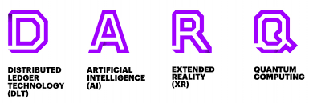

Figure 1: DARQ

How about we see DARQ parts- Distributed Ledger Technology, Artificial knowledge, Extended Reality, and Quantum Computing. This all gives the most ideal approach to deal with information, store large information, further develop work quality and quick item making and give the best security to our information.

  - Applications of DARQ-

Let us take a look at the various uses of DARQ.
1.2.1 Transfer of money and information
DARQ will help us to send money and information in an immutable manner.

    - Automate Cities
Using artificial intelligence we will be able to automate cities to some extent.

    - Entertainment
Using virtual reality we will be able to take entertainment to next level.
    - Solve various Problems
Using Quantum Computers some complex problems might be solved.

- DISTRIBUTED LEGER(dlt)/blockchain Technology

type of transaction technology which would allow Technologies to transfer money as well as important details it was introduced by Bitcoin it is a decentralized network normally if our data is stored on a cloud it may get hacked or corrupted, the nature of a decentralized ledger makes them immune to a cybercrime
- It eliminates the need for a central authority to keep a check against validation
- It is a technology infrastructure and protocols that allow simultaneous access validation record updating in an immutable manner.
- It works by including the identifier of the last block into the identifier of the following block to create an Unbreakable and immutable chain.
- As more blocks are added, a computer connects to the network of blockchain, it is called a node. They support the network through validation and relaying transactions. They are paid through incentives like Bitcoin.

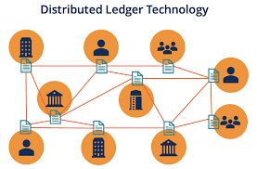

Figure 2: DLT
EXAMPLE- Mysterium Network is a decentralized and anonymous network and works on the principle of peer-to-peer Technology here people become nodes by sharing their IP so that other people can overcome geographical restrictions like Netflix, cloud gaming, and they are given an incentive of MYST token.
Applications of Blockchain technology-
- Reliability – Since the blockchain has no central point of failure, it is almost impossible that it could fail as the whole system is distributed via countless nodes
- Data Integrity – The so-called “hashing” in the blockchain makes it almost impossible to change data.
- Analysis and transparency – The Bockchain’s unchangeable and comprehensible system makes it possible to make transactions and their effects on the various contractual partners visible. This helps with transparency and accurate analysis, as this information cannot be changed.


Figure 3: A ledger used to store crypto

- A.I.(ARTIFICIAL INTELLIGENCE)
When a machine becomes intelligent it is said to possess artificial intelligence.
Let's take examples to understand better Tesla who CEO is none other than the famous billionaire Elon Musk has launched autopilot cars. Now let's see how it works, the car uses cameras and ultrasonic sensors to sense the environment around the car and takes decisions accordingly.
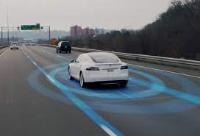
Figure 4: An autopilot car
Another good example is Google search, have you ever noticed that when you search for something on Google it automatically shows you some suggestions like if you search for cute cat photos, Google would show you pictures of some cute kittens. Now, how does Google know whether the kitten is cute or not well that’s A.I.
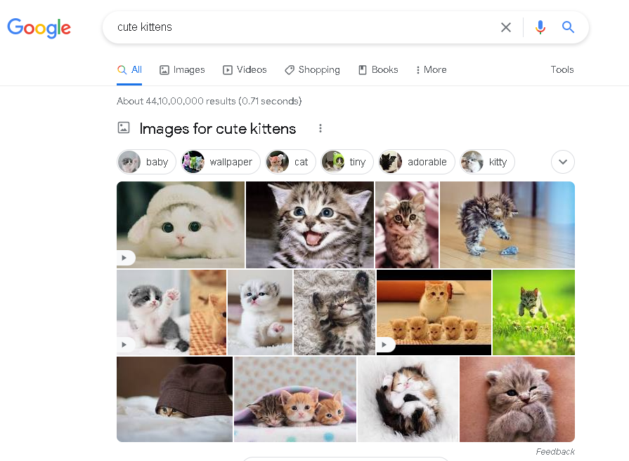
Figure 5: Search results for cute kittens

Some AI applications-
- Online shopping and advertising
  - Artificial intelligence is widely used to provide personalized recommendations to people, based for example on their previous searches and purchases or other online behavior. AI is hugely important in commerce: optimizing products, planning inventory, logistics, etc.
- Digital personal assistants
  - Smartphones use AI to provide services that are as relevant and personalized as possible. Virtual assistants answering questions, providing recommendations, and helping organize daily routines have become ubiquitous.
- Smart homes, cities, and infrastructure
  - Smart thermostats learn from our behavior to save energy, while developers of smart cities hope to regulate traffic to improve connectivity and reduce traffic jams.
- Cars
  - While self-driving vehicles are not yet standard, cars already use AI-powered safety functions.

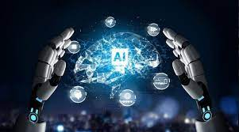
Figure 6: AI

- Extended Reality
Extended Reality is a blend of AR, VR, and MR. Increased Reality, Virtual Reality, Mixed Reality on account of this, the amusement world has changed. Presently you can travel anyplace utilizing VR. simply pause for a moment and wear a VR headset and partake in your excursion.
Utilizing an AR adds an object in reality. Simply wear VR or open a versatile camera and check out you will see objects around you. You can collaborate with 3d articles. The best illustration of AR is the Pokemon Go game. MR is Mixed Reality is a mix of AR and VR
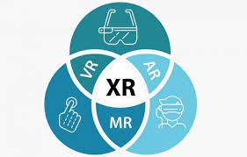
Figure 7: Extended Reality
  - VR/ Virtual Reality
As opposed to augmented reality, in a computer-generated simulation experience, clients are completely submerged in a reproduced advanced climate. People should put on a VR headset or head-mounted presentation to get a 360 - degree perspective on a counterfeit world that tricks their cerebrum into accepting they are, e.g., strolling on the moon, swimming under the sea, or ventured into whatever new world the VR designers made. The gaming and media outlet were early adopters of this innovation; notwithstanding, organizations in a few ventures like medical care, development, designing, the military, and more are observing VR be exceptionally helpful.

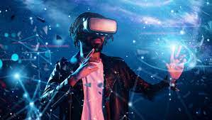
Figure 8: Virtual Reality
  - Augmented Reality
In expanded reality, virtual data and articles are overlaid on this present reality. This experience improves this present reality with advanced subtleties like pictures, messages, and activity. You can get to the experience through AR glasses or utilizing screens, tablets, and cell phones. This implies clients are not detached from this present reality can in any case connect and see what's happening before them. The most notable instances of AR are the Pokémon GO game that overlays computerized animals onto this present reality or Snapchat channels that put advanced articles like caps or glasses onto your head.
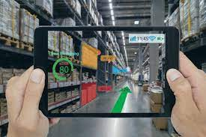
Figure 9: Augmented Reality
4.3 Mixed Reality
In blended reality, computerized and certifiable articles coincide and can interface with each other progressively. This is the most recent vivid innovation and is in some cases alluded to as half breed reality. It requires an MR headset and significantly more preparing power than VR or AR. Microsoft's HoloLens is an incredible model that, e.g., permits you to put computerized objects into the room you are remaining in and enable you to twirl it around or communicate with the advanced article in any capacity conceivable. Organizations are investigating ways they can give blended reality something to do to take care of issues, support drives, and improve their organizations.
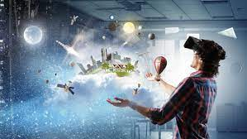
Figure 10: Mixed Reality
4.4 Applications Of Extended Reality
- Retail: XR gives customers the ability to try before they buy. Watch manufacturer Rolex has an AR app that allows you to try on watches on your actual wrist
- Entertainment: As an early adopter, the entertainment industry will continue to find new ways of utilizing immersive technologies.
- Real estate: Finding buyers or tenants might be easier if individuals can “walk through” spaces to decide if they want it even when they are in some other location.

- Quantum Computing
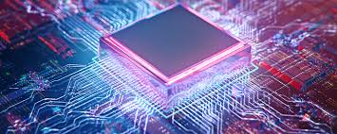
Figure 11: Quantum Computing
5.1 What is Quantum Computing?
Have you ever wondered why computers are getting thinner? Well, the answer to this is that earlier large transistors were used but now in quantum computers subatomic particles have taken their place. Quantum computing is an area of computing focused on developing computer technology based on the principles of quantum theory (which explains the behavior of energy and material on the atomic and subatomic levels). Computers used today can only encode information in bits that take the value of 1 or 0—restricting their ability.
Quantum computing, on the other hand, uses quantum bits or qubits. It harnesses the unique ability of subatomic particles that allows them to exist in more than one state (i.e., a 1 and a 0 at the same time).
5.2 Applications of Quantum Computers-
- Cybersecurity
- Financial Modelling
- Weather Forecasting

6. Summary and Future Work
This constellation of technologies retains the power to reshape organizational policies, processes, practices, and end-consumer experiences. The tech is becoming increasingly capable, reliable, and relevant. Businesses that wish to remain at the forefront of innovation may benefit from continuing to investigate the businesses opportunities related to DARQ.
It has the potential internet had in the 1990s so the organizations which will realize its potential will profit significantly.

References

- https://www.cybertalk.org/
- https://www.forbes.com/
- https://www.geeksforgeeks.org/darq-technology-powerhouse-of-future/

